**Results from Twitter mining**

Wei

4877 Tweets were streamed from Twitter on Aug 18th with key word search including "oculus rift", "oculus", "rift", "vr", "htc vive", "google cardboard”. And only English tweets are tracked. Using some text mining methods excluding stop-words and others, we found the following 50 features are most talked features. With some manual cleaning, the chart below shows the words are most likely to appear in the VR discussion on the Twitter. This analysis is mostly for exploratory purpose. It helps to reveal main application of the VR gears, main competitors in the market and relevant entities.

50 Key features summarized by machine learning

['360', 'add', 'amp', 'ar', 'arkham', 'batman', 'booming', 'bringing', 'camera', 'cardboard', 'china', 'community', 'degree', 'future', 'game', 'games', 'gaming', 'g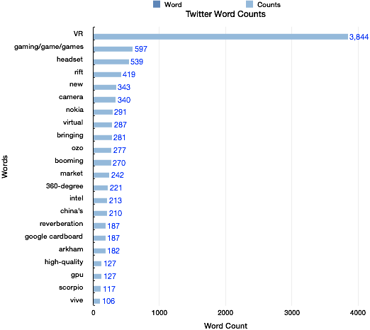oogle', 'gpu', 'headset', 'high', 'hold', 'intel', 'join', 'lack', 'live', 'market', 'minutes', 'modules', 'new', 'nokia', 'oculus', 'ozo', 'pizza', 'playstation', 'post', 'project', 'quality', 'reality', 'reverberation', 'rift', 'rt', 'tech', 'tweet', 'video', 'virtual', 'virtualreality', 'vr', 'world', 'xbox']

We found

1) gaming still the most hot words. And currently the games like Minecraft developed by Oculus are talked a lot (data not shown here though). Beyond Gaming, other application in movie (such as Arkham Batman and other entertainment such as live view of landscapes.

2) Another interesting word is reverberation. VR is about visual and people now are discussing about the audio component too. It might be things VR company keeping on their watch-list.

http://designingsound.org/2014/05/audio-and-vr

3) Oculus rift are most likely to be mentioned than other competitors, showing strong stand in the industry.

4) You may notice Intel is very often mentioned. They have a project Alloy which is a high-end VR which incorporate both CPU and VR glasses into one entity.

<http://www.thehindu.com/business/Industry/intel-unveils-merged-reality-with-project-alloy-device/article9008432.ece>

5) Why Nokia is here too? It’s about their 360-degree OZO camera.

6) Besides the VR content such as game and others, people also talked about the gear as a hardware with their Graphic Processing Unit GPU) .

[('vr', 2455),

('rt', 1593),

('#vr', 1100),

('rift', 419),

('headset', 408),

('-', 385),

('gaming', 351),

('new', 343),

('camera', 340),

('/', 333),

('nokia', 291),

('vr,', 289),

('virtual', 287),

('bringing', 281),

('ozo', 277),

('oculus', 271),

('booming', 270),

('reality', 251),

('market', 242),

('360-degree', 221),

('#virtualreality', 214),

('intel', 213),

("china's", 210),

('&amp;', 203),

('reverberation', 187),

('arkham', 182),

('google', 154),

('cardboard', 150),

('join', 141),

('post', 141)]